**SIR SYED UNIVERSITY OF ENGINEERING & TECHNOLOGY**

**COMPUTER SCIENCE AND INFORMATION TECHNOLOGY DEPARTMENT**

**SPRING 2021**

**DATABASE SYSTEM (CS-329)**

**Assignment 2**

Semester: 5TH Batch: 2019

Due Date: 28 -May-2021 Max Marks: 5

Name: Munib ul hassan

Roll No: 2019-CS-037

Section: “A”

**Question: Convert the following tables into their Normalized form**

**1:**

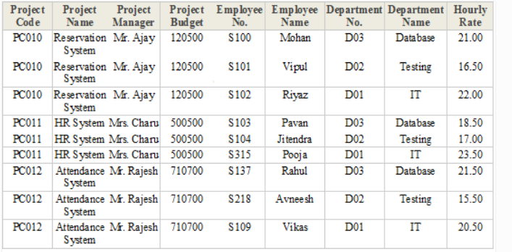

**Where**

**Project Code, Employee No, Department No Are Primary keys**

2:

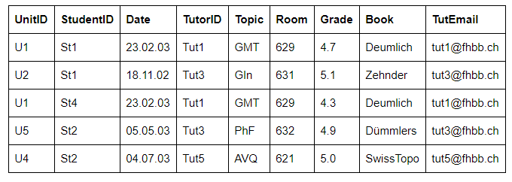

**Where**

**UnitID, Studentid , TutorID Are Primary keys**

3:

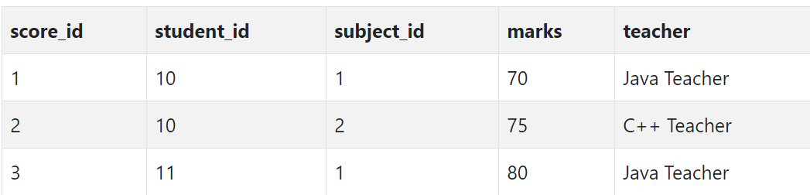

**Where**

**Student ID , Subject ID,Score ID are Primary keys**